Setting up Application Environment

Create Flask Project

|  |  |
| --- | --- |
| Team ID | PNT2022TMID49165 |
| Project Name | Skill/Job Recommender Application |

Step 1: Install python latest version

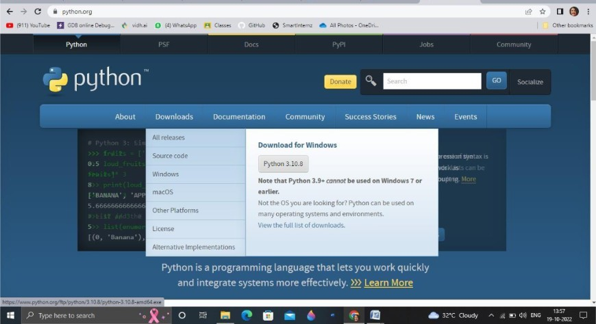

Step 2: Install Flask using command pip install flask

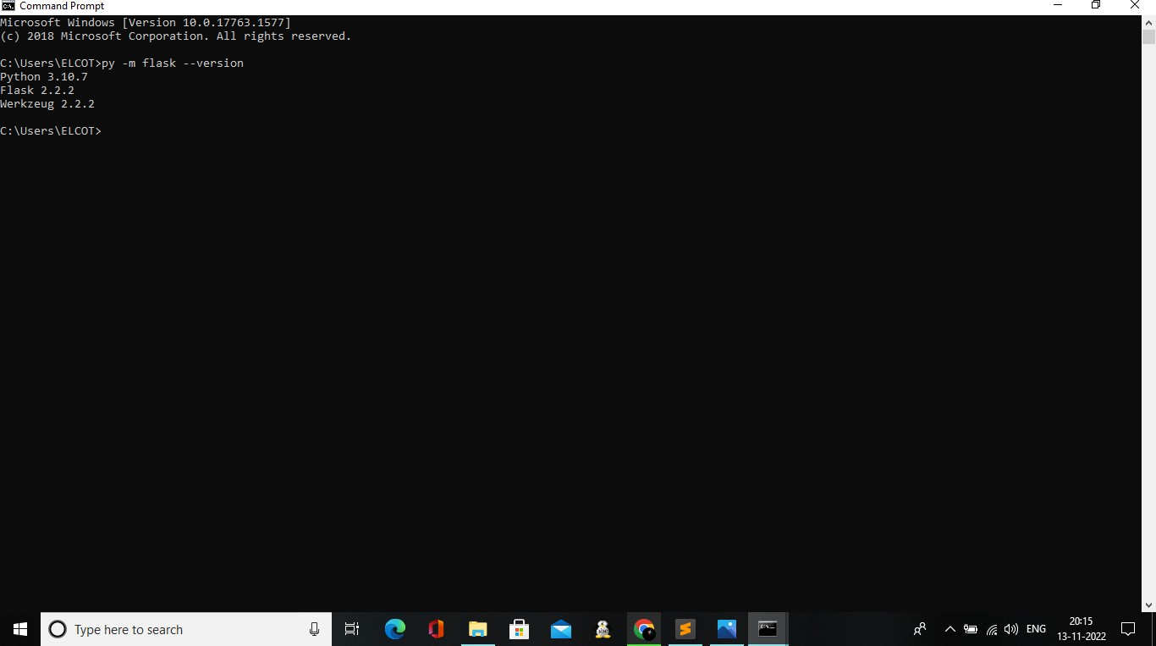

Step 3: Open new python file and start coding

from flask import Flask app = Flask( name ) @app.route("/")

def home(): return "hi!"

Step 4:Run the program in cmd using the command python -m flask run

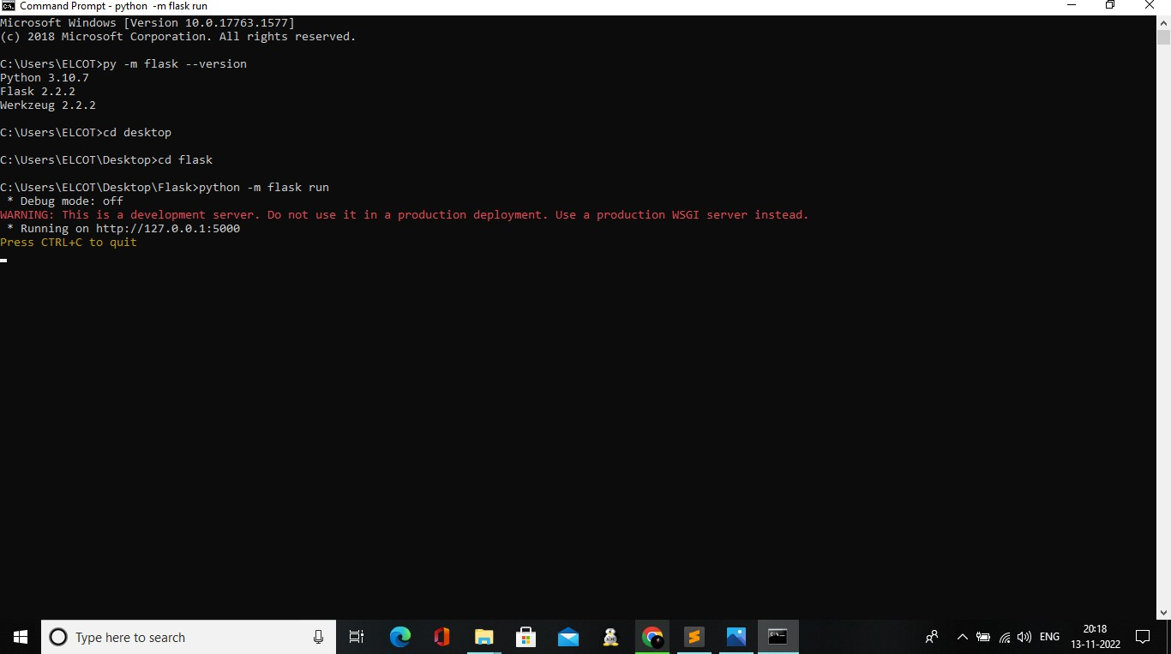

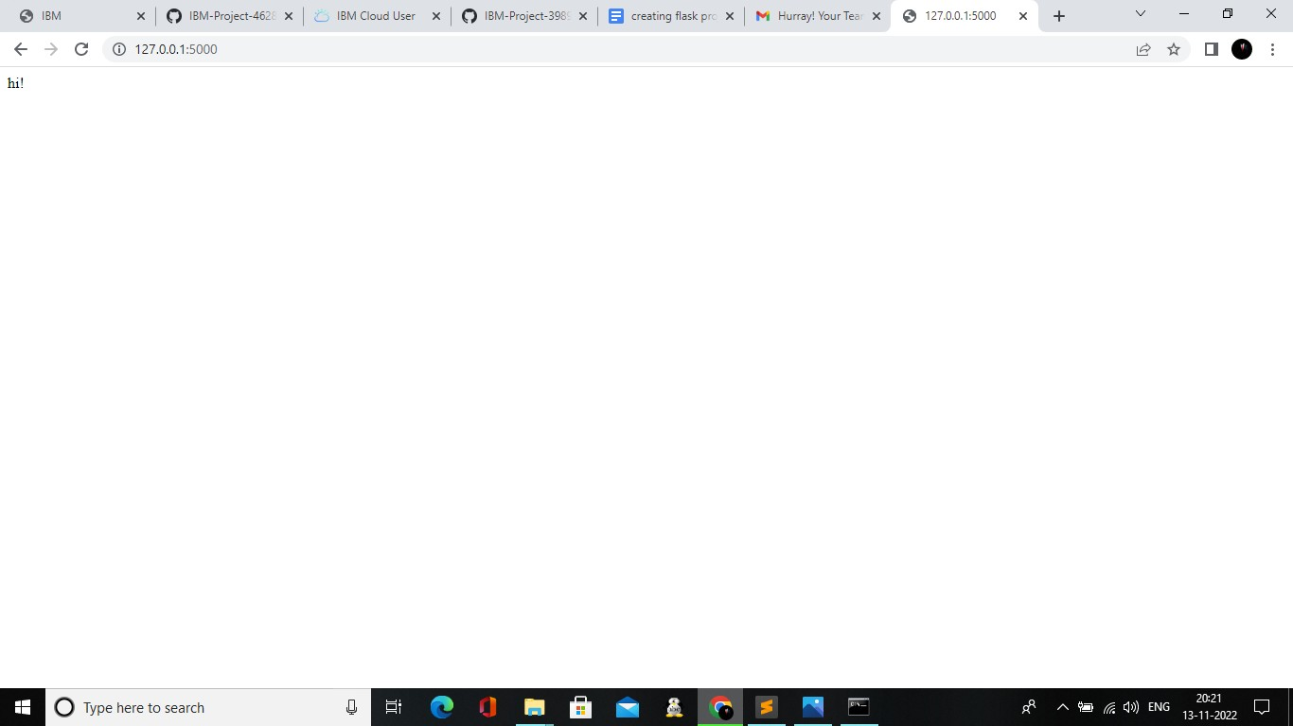Step 5: Open the ip in browser